LIST OF EQUIPMENT

Sl. No. | Description Equipment | Quantity
1 | Drillto ZT25 | 1 Nos
2 | Atlas Capco 186 | 1 Nos
3 | Digitracker Falcon F2 | 1 Nos
4 | Becu | 2 Nos
5 | Belcha | 10 Pcs
6 | Truck | 1 pcs
7 | Excavator | 1 Nos
8 | Generator | 1 pcs
9 | Welding Set | 3 SET

List of professional & technical Personnel of the Firm

Sl. NO. | Name | Designation | Educational Qualification
01 | Engr. shahidul islam | Enginner | B.Sc. Engg. (civil) mieb f-4021
02 | Engr. bibhuti ranjon talukder | Supervisor | B.Sc. Engg. (Civil)
03 | Monirul Haque | Site Engineer | Diploma in Engg. (Civil)
04 | Milon Chandra Bishwash | Site Engineer | Diploma in Engg. (Civil)
05 | Mr. Hasan Ahmed Hira | Supervisor | H.S.C
06 | Md. Headayat Ullah | Foreman | Class- VII
07 | Md. Jalal Uddin | Supervisor | H.S.C
08 | Md. Moniruddin | Supervisor | H.S.C
09 | Md. Soujaudoula | Supervisor | H.S.C
10 | Md. Shahidul Islam | Labour | H.S.C
11 | Md. Ariful Islam | Driver | H.S.C
12 | Md. Nirob | Labour | S.SC
13 | Md. Nazmul Islam | Labour | S.S.C
14 | Mozzem | Labour | Class VII
15 | Md. S I Shemul | Labour | Class V

COMPANY PROFILE
Drill Tech INternational
HORIZONTAL DIRECTION
DRILLING (HDD)

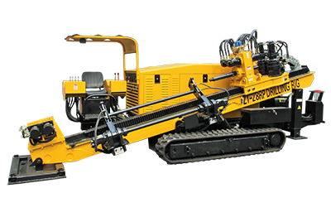

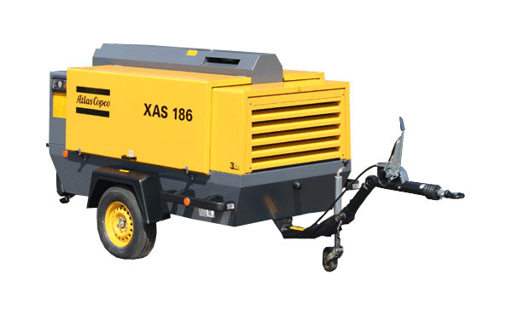

ABOUT US

The DrillTech International is a leading provider of Horizontal Directional Drilling throughout Bangladesh. Horizontal directional drilling or HDD is a trenchless method of installing underground pipes, conduits and cables in a shallow arc along a prescribed bore path by using a surface-launched or pit-launched drilling rig. Directional boring is used when trenching or excavating is not practical. With HDD, it is possible to drill under roadways, river crossings, and mountainous regions with less equipment at a lower cost, with a minimum period of time and minimal impact on the surrounding area.
DrillTech International has a team of experienced managers, engineers’ backgrounds in the Computer Engineering civil engineering and construction industry. We are also a civil and construction company that has built a strong reputation for delivering a quality service, on time, and at a competitive price.
VISION

To satisfy the needs of our customers and give them a one stop solution with high standards that will add value to their operations in order to give them the competitive edge.

MISSION

DrillTech International’s mission is to develop and offer to its customer’s new and innovative solutions to our clients in Horizontal Directional Drilling industry, in the industries of Telecommunications, Electrical and Infrastructure. Our pledge is to add value to our Client's operations, establish and build lasting, mutually beneficial relationships by exceeding their expectations through exceptional performance by every member of our company team.

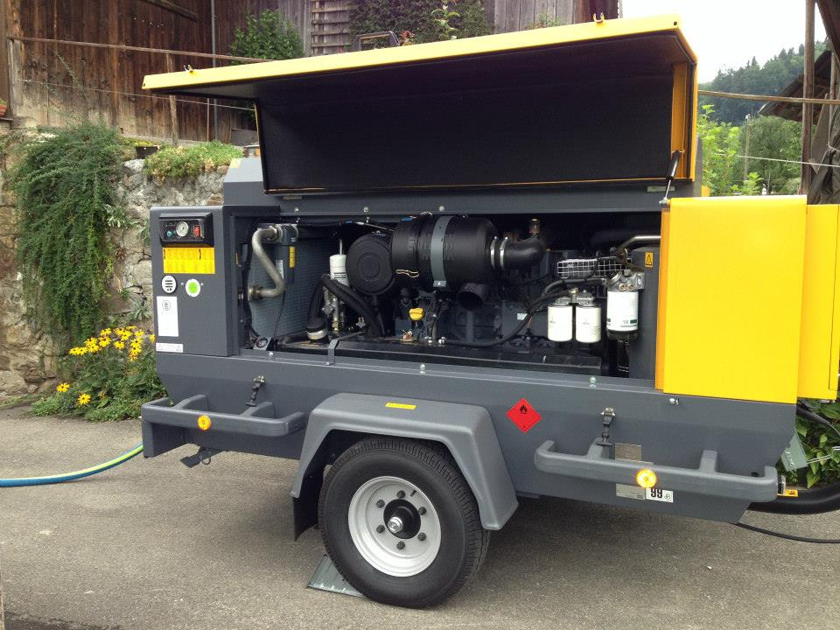

Our commitment to innovation and excellence invariably results in a successfully completed project for both contractor and client. We understand and promote the idea of working as a partnership with our clients to ensure their goals are met.

Further to provide our teams with an honest working environment where every employee, individually and collectively, can dedicate themselves to provide our clients with remarkable service and professional integrity.

MANAGEMENT TEAM
NO. NAME POSITION

1 | Abdullah Al Beruni Saikot |  | C.E.O
 | Phone No. 01711223948
2 | Mohammad Shaukat Ali |  | C.T.O
 | Phone No. 01715062935
3 | Mohammad Bazlul Kabir |  | C.F.O.
 | Phone no. 01715159667

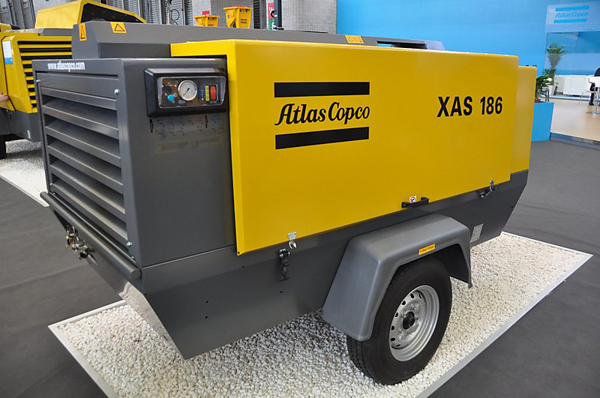

Drilling

Taking initial experiences of deep geothermal wells as a basis,

DrillTec has become a well-known partner of the E&P industry and now executes wells of up to 5,000 m.
Our range of services includes:

- Engineering services:planning, local authorities procedures, drilling documentation
- Coordination and additional services „Integrated Service“

- Drilling of wells for hydrocarbons, geothermal and gas storage wells

- Difficult workover services

- Slanted drilling, multilateral wells

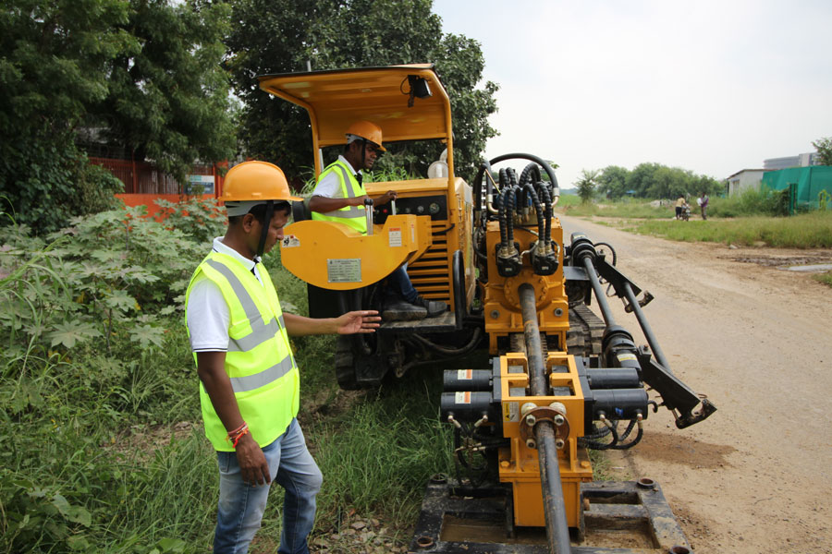

Horizontal Directional Drilling (HDD)

The beginnings of our company lie in this field – the trench-less installation of pipelines. That is how Drill Tech – even under the most difficult conditions – has been carrying out major drilling projects with diameters of up to 56" (1,400 mm) and drilling lengths of more than
Our range of services includes:
- Feasibility studies

- Planning, coordination and execution of complex HDD projects as part of EPC contracts

- Offshore connection of oil/gas production platforms

- Shore crossings for oil/gas reservoirs and sea water desalination plants

- Outfalls for sewage

- Crossings (e.g. mountain crossings, river crossings)

- Drainage and horizontal filter wells

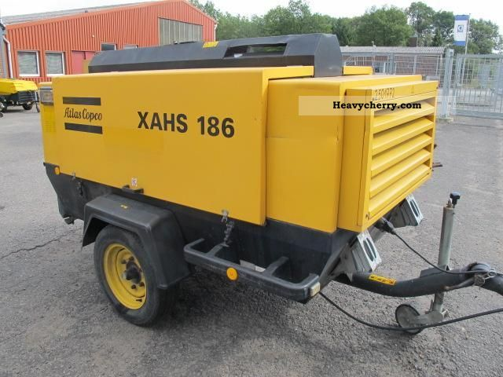

Locating and guidance

Location and guidance of the drilling is an important part of the drilling operation, as the drilling head is under the ground while drilling and, in most cases, not visible from the ground surface. Uncontrolled or unguided drilling can lead to substantial destruction, which can be eliminated by properly locating and guiding the drill head.

There are three types of locating equipment for locating the bore head: the walk-over locating system, the wire-line locating system and the gyro guided drilling, where a full inertial navigation system is located close to the drill head.

- Walk-over locating system — In first system a sonde, or transmitter, behind the bore head registers angle, rotation, direction, and temperature data. This information is encoded into an electro-magnetic signal and transmitted through the ground to the surface in a walk-over system. At the surface a receiver (usually a hand-held locator) is manually positioned over the sonde, the signal is decoded and steering directions are relayed to the bore machine operator.

- Wire-line locating system — The wire-line system is a Magnetic Guidance System. With a Magnetic Guidance System (MGS), the tool reads Inclination and Azimuth. The MGS, also has a secondary means of location verification utilizing wire grids laid on the ground surface. It is the only system that has the capability of verifying the location. This information is transmitted through the wire-line fitted within the drill string. At the surface, the Navigator in the drill cab

performs the necessary calculations to confirm the parameters have been met. The MGS even without the use of the wire grid has been accurate to almost 2 km with an accuracy of 1.5 m.

- Gyro-based locating system — The gyro based system is fully autonomously working and therefore one of the most accurate system where sufficient diameter (200 mm) is available and where long distances (up to 2 km) have to be performed with small deviation (less than 1 m position error).

All three systems have their own merits, and a particular system is chosen depending upon the site requirements.
