M/s. M. A. Hakim Waterways Dredging started the business of sand supply as a fulfillment of the need for sand for upgrading the challenging terrain of the Bangladesh Delta, being an area that is constantly undergoing rapid infrastructural development.
The journey started several years ago, with M/s. M. A. Hakim Waterways being in the business of bulk purchase of sand from local suppliers and resale to contractors. Progress came in the business of sand supply with the need to lease dredgers (needed for the stockpiling of sand for sale to individual suppliers and contractors). In 2012, M/s. M. A. Hakim Waterways Dredging was formed for the services of dredging, reclamation, sand filing, haulage, with the headquarters located at the ultra-modern Operational Base facility at every division in Bangladesh.
Removal of sand and gravel is the most popular use of a dredge worldwide. M/s. M. A. Hakim Waterways Dredge Systems offers a multitude of different options from a land based Bucket ladder to deep digging floating clamshell dredges to high pressure jet suction or cutter suction dredges. M/s. M. A. Hakim Waterways Dredge Systems dredges are designed for low power consumption and in fact our clamshell systems offers a regenerative system which lowers the energy requirements even further. No matter what your sand & gravel production requirements may be M/s. M. A. Hakim Waterways Dredge Systems is capable of satisfying your requirements.

M/s. M. A. Hakim Waterways Dredging division is managed by professionals in various endeavors who sought to bridge the gap created by environmental and infrastructural developmental needs in the Bangladesh. It is currently one of the subsidiaries of the TradeShore Group.
- Achieving a leadership position in the supply and sale of sand, delivering cheap, affordable and reliable sand in quality and quantity.
- To be highly reputable and reliable dredging, reclamation/sand filling experts and miners of sand, gravel and other aggregates ensuring confidence in dredging activity.
- To consistently and promptly supply sand and filling materials to customers within the shortest possible time, ensuring the highest level of customer satisfaction and value for money.
- Provide equipment, trucks and construction tools to customers at affordable rental prices in a straight non-ambiguous business operation.
- Improving confidence for the usages of pre-molded bricks and interlocking stones, ensuring customers save cost and time in molding activities.
- Attaining highly respected professional organizations that provide sand, dredging and reclamation services, hiring of new modern reliable equipment and trucks thereby determines standard in the construction industry.
- Consistently and continuously providing for the motivation, enhancement of company human resources through development of welfare programmes, human resources comfort and intrinsic and extrinsic support to human resources as well as development of capacity.

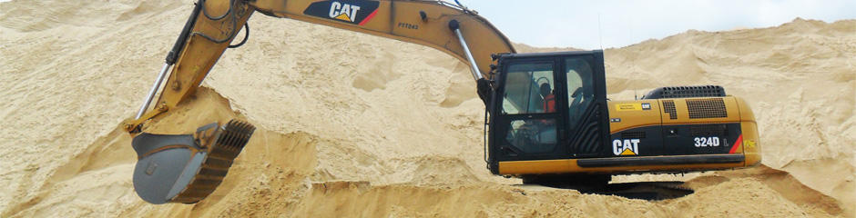
M/s. M. A. Hakim Waterways sand, which is the best grade of sand, is produced and supplied by M/s. M. A. Hakim Waterways Dredging. The sand can be used for multiple purposes such as sand-filling, road construction, molding of blocks, sand blasting as well as glass production. M/s. M. A. Hakim Waterways sand is further repackaged for sale into different types of loading sizes for the affordability of her customers.
Supply of M/s. M. A. Hakim Waterways Sand is based on the quantity of sand loading. The loading is basically done by excavator machines which are of two categories: the 324D excavator with a small bucket(SBK) and the bigger excavator 336D, which has a big bucket(BBK). The small bucket (SBK) loads 3.2m³ and the big bucket(BBK) loads 4m³.
Therefore, the various packages of sand loading are:
- One Small Bucket (1SBK)……………Pinch Load= 3.2m³…………………..N2,000.00
- Two Small Bucket (2SBK)…………..Small Load= 6.4m³……………………N4,000.00
- Three Small Bucket (3SBK)…………Jolly Load=9.6m³…………………….N6,000.00
- Four Small Bucket ( 4SBK)………….Supplier Load =12.8m³……………..N8,000.00
- Five Small Bucket (5SBK)……………Owner Load =16m³…………………..N10,000.00
- Six Small Bucket (6SBK)…………….Maxy Load = 19.2m³…………………N12,000.00
Using the Big Bucket loading the categories are as follows;
- One Big Bucket (1BBK)……………….Min Load = 4m³………………………….N2,600.00
- Two Big Bucket ( 2BBK)………………Big Load = 8m³…………………………..N5,200.00
- Three Big Bucket (3BBK)…………….Balance Load=12m³…………………….N7,800.00
- Four Big Bucket (4BBK)……………..Large Load= 16m³………………………N10,400.00

Vision
To be the leading dredgers of sand, gravel and other aggregates. Suppliers of cheap, reliable quantity and quality sand. Providers of premium dredging, reclamation, sand-filling and construction services for the transformation of the Bangladesh delta environment into a glorious haven.
Our Mission
Dredging, reclamation and sand-filling the underwater environment to solid ground. Stockpiling sand for supply of reliable quality and quantity at clients’ project sites with modern trucks thereby ensuring a sustainable partnership making building and construction affordable to every individual.

Overview
M/s. M. A. Hakim Waterways is endowed with various forms of new heavy-duty machinery. To view the details about any, just click on the associated thumbnail image below
Value Statement
Building confidence in sand supply, dredging, reclamation by promoting sincerity, friendliness and customer satisfaction.

Core Values
- Trust, honesty, sincerity and discipline in all business transactions.
- Friendliness, innovation, professionalism and style.
- Value for people’s property and care to company’s property.
- Unprecedented customer satisfaction.
- Working together and believing in the Team.

Sand Supply
M/s. M. A. Hakim Waterways has at each point in time, a minimum of five hundred thousand cubic (500,000 m) of sand stockpiled at the operational base for sale to individuals, suppliers, developers and contractors. This sand comes in different grades from fine, coarse, gravel and filling sand. They are also supplied in different loading units dependent on the size of loading. The client can order units known as pinch load, small load, supply load, jolly load and owner load. M/s. M. A. Hakim Waterways also sand fills swampy areas for clients. M/s. M. A. Hakim Waterways hauls sand from the operational site to the desired point of the client’s project site as may be required.

